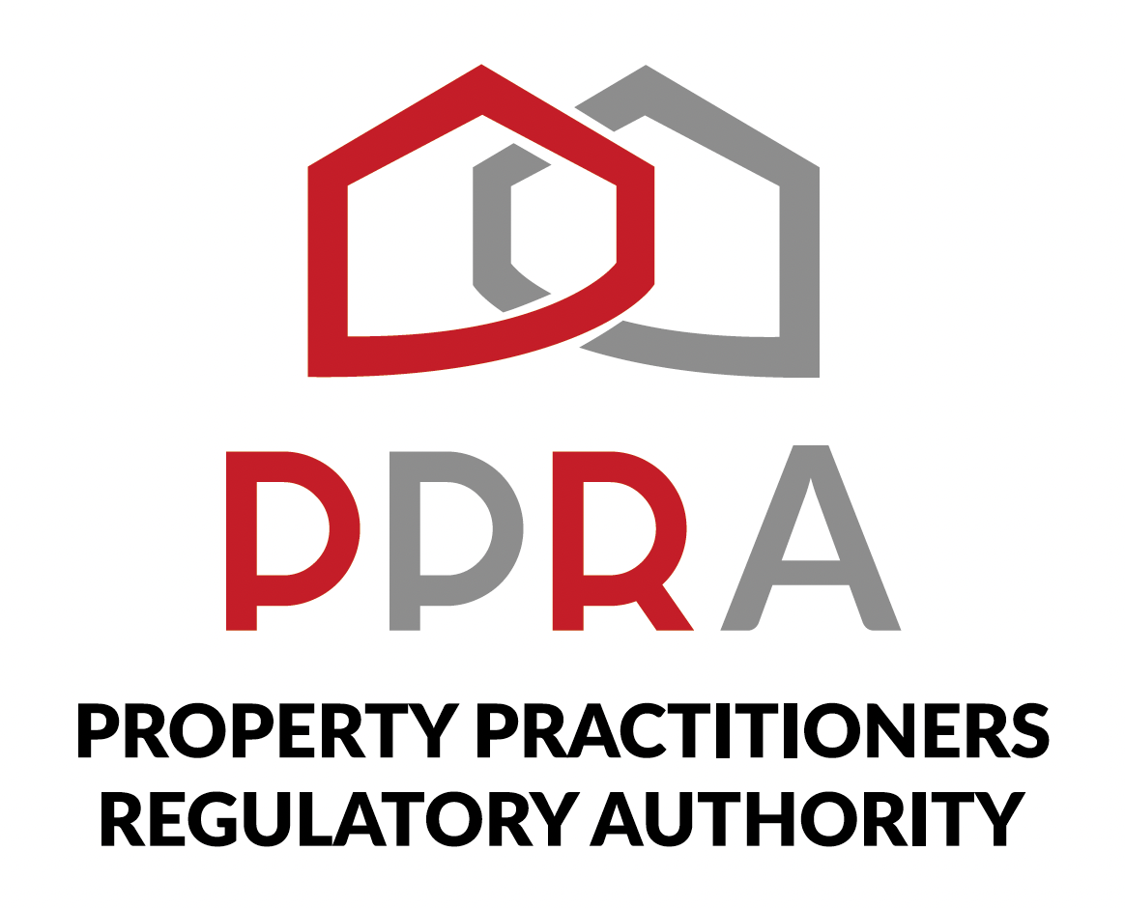
REAL ESTATE POST-TRAINING SUPPORT PROGRAMME

LEARNER WORKBOOK
PORTFOLIO REVIEW, ASSESSMENT & CERTIFICATION

Session | Session 9 of 10
Date | 01 December 2026
Time | 09:00–11:00
Facilitator | Hlubi Dlomo
Format | Virtual Training / Masterclass

Portfolio Review • Competency Assessment • Evaluation • Certification • Future Roadmap

1. Welcome
Welcome to Session 9. This session brings together the practical work completed during the Post-Training Support Programme. You will review your evidence, complete the final competency self-assessment process, provide programme feedback and clarify your next steps.
Important
This workbook is designed to help you organise evidence, reflect on your readiness and prepare for the programme’s final review and certification process.

2. Session Information
Item | Details
Session | Session 9 of 10
Masterclass | Portfolio Review, Assessment & Certification
Date | 01 December 2026
Time | 09:00–11:00
Facilitator | Hlubi Dlomo
Format | Virtual Training / Masterclass

3. What You Will Do
- Review your practical evidence from the programme.
- Organise and confirm the evidence you have available.
- Reflect on your overall operational and sales readiness.
- Complete the final competency self-assessment.
- Identify any gaps or areas where you need clarification.
- Provide feedback on the Post-Training Support Programme.
- Record your immediate next steps and future roadmap.

4. Portfolio Evidence Review
Use this checklist to review the evidence you have compiled. Tick or note the status of each item.
Evidence Area | Available / Reviewed | Notes / Follow-Up
Digital readiness / platform participation
PPRA practice-readiness activities
Sales and mandate activities
Digital marketing activities
Client management activities
Personal branding activities
CRM / client pipeline activities
Business management / business plan
CIPC / BizPortal learning activity
SARS / tax administration learning activity
Financial literacy activities
Other practical outputs

5. Portfolio Reflection
Which practical activity from the programme can you apply immediately in your real estate work?
________________________________________________________________________________
________________________________________________________________________________
Which item in your portfolio best demonstrates your readiness for early practice?
________________________________________________________________________________
________________________________________________________________________________
Which evidence item needs improvement, completion or clarification?
________________________________________________________________________________
________________________________________________________________________________
What practical skill do you still need to practise?
________________________________________________________________________________
________________________________________________________________________________

6. Final Competency Self-Assessment
Use this section to reflect on your current readiness. This is a learner self-assessment. It is not a scored examination. No marks or scores are allocated.
Area | My Reflection | Support / Clarification Needed
PPRA and professional practice readiness
Sales and mandate readiness
Digital marketing and lead generation
Client management and communication
CRM and pipeline management
Business management and planning
CIPC / business administration awareness
SARS / tax administration awareness
Real estate financial literacy
Overall operational and sales readiness

7. Practical Readiness Reflection
- Describe how you would move a prospective client from initial inquiry through follow-up and the next stage of the sales process.
- Describe how you would use the practical tools developed during the programme in your day-to-day work.
- Identify one area of your practice that requires additional support or learning.
- Identify one action you will take immediately after completing the programme.
________________________________________________________________________________
________________________________________________________________________________
________________________________________________________________________________
________________________________________________________________________________
________________________________________________________________________________
________________________________________________________________________________
________________________________________________________________________________
________________________________________________________________________________

8. Programme Evaluation & Feedback
- Which parts of the programme were most useful to you?
- Which topics would you like more support with?
- Which practical tools or templates are you most likely to continue using?
- What could improve future post-training support programmes?
________________________________________________________________________________
________________________________________________________________________________
________________________________________________________________________________
________________________________________________________________________________

9. My Future Roadmap
Priority | Action I Will Take | Target / Timing
Professional readiness
Sales / client development
Business / administration
Digital / marketing
Continued learning / CPD

10. Outstanding Items
Item | What I Need To Do | Who / Where I Will Get Support

11. Learner Confirmation
I confirm that I have reviewed my practical evidence, reflected on my learning and readiness, and completed the learner-facing assessment and programme feedback activities for Session 9.
Learner Name | Signature | Date

