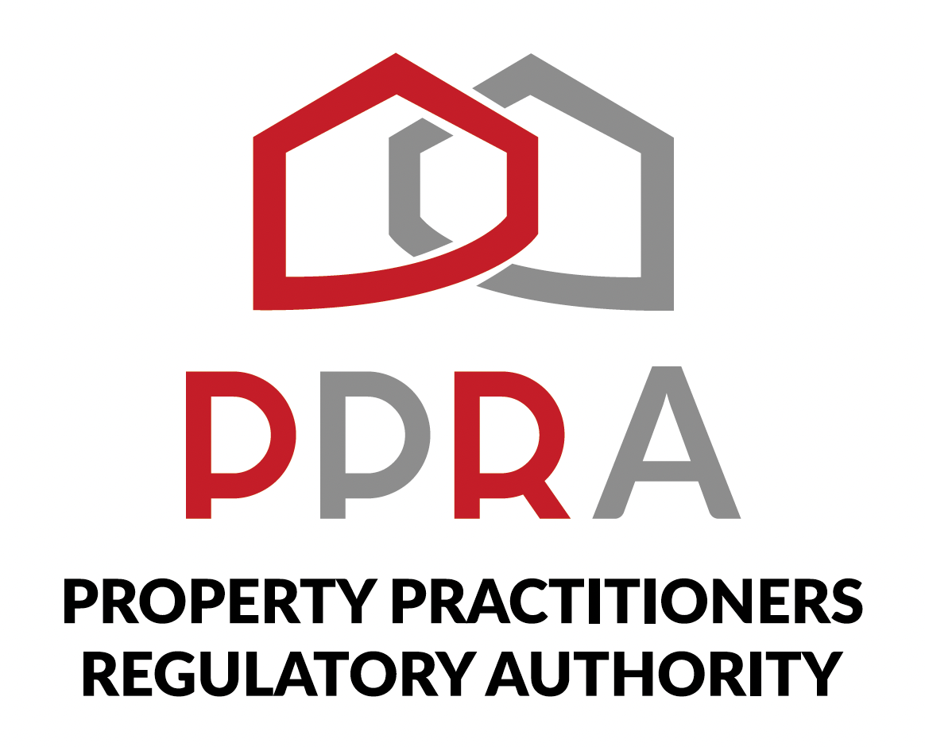
REAL ESTATE POST-TRAINING SUPPORT PROGRAMME
LEARNER WORKBOOK
CRM, CLIENT PIPELINE & BUSINESS MANAGEMENT
Item | Detail
Session | Session 7
Date | 17 November 2026
Time | 09:00–11:00
Facilitator | Hlubi Dlomo

Welcome
Welcome to Session 7. This workbook helps you turn CRM, client-pipeline and business-management concepts into practical tools for your real estate practice.

1. Session Information
Item | Detail
Session | Session 7
Date | 17 November 2026
Time | 09:00–11:00
Focus | CRM, Client Pipeline & Business Management
Delivery | Virtual masterclass
Facilitator | Hlubi Dlomo
The approved session covers CRM systems in real estate, lead capture, qualification, segmentation, structured follow-up, workflow alerts, client reminders, transaction milestones, POPIA/client data privacy and consent forms, and a lean one-page business plan with targets, budgets and KPIs.

2. Learning Objectives
- Understand the role of a CRM in real estate.
- Capture, qualify and segment leads.
- Create structured follow-up sequences.
- Use workflow alerts, reminders and transaction milestones.
- Identify client data privacy and consent considerations within the session scope.
- Create a lean one-page business plan with targets, budget and KPIs.

3. Activity 1 – My CRM Process
CRM Stage | What I Need to Capture / Do
Lead capture
Lead qualification
Lead segmentation
Follow-up
Client history
Workflow / reminders
Transaction milestones

4. Activity 2 – Lead Capture
Field | Example / My Entry
Lead name
Contact details
Lead source
Buyer / seller / other
Requirement / enquiry
Current status
Next action
Follow-up timing

5. Activity 3 – Lead Qualification & Segmentation
Lead | What I Need to Clarify | Segment / Group | Next Action

6. Activity 4 – Structured Follow-Up
Prospect | Current Stage | Follow-Up Action | Timing | Reminder / Workflow
My follow-up sequence for one prospect:
Step | Action | Timing | Record / Reminder
1
2
3
4

7. Activity 5 – Workflow Alerts & Transaction Milestones
Workflow / Milestone | What Needs to Happen | Reminder / Alert | Who Is Responsible

8. Activity 6 – Client Data Privacy & Consent
Use this activity to capture your understanding of the client-data privacy and consent considerations discussed in the session.
Question | My Response
What client information do I capture?
Why is the information needed?
How will I handle it appropriately?
Where do consent forms fit into my process?
What information should not be unnecessarily exposed?
What questions require further clarification?

9. Activity 7 – My One-Page Real Estate Business Plan
Business Plan Element | My Plan
Business focus
Target market
Business targets
Key activities
Budget
KPIs
Review cycle
My top business targets:
1. __________________________________________________________________________________
2. __________________________________________________________________________________
3. __________________________________________________________________________________
My key KPIs:
1. __________________________________________________________________________________
2. __________________________________________________________________________________
3. __________________________________________________________________________________
4. __________________________________________________________________________________

10. My 30-Day Business Management Action Plan
Action | First Step | Timing | How I Will Track It
Improve CRM / lead capture
Qualify and segment leads
Implement follow-up sequence
Use reminders / milestones
Review client data process
Implement business plan

11. Reflection
What is the most useful CRM practice I learned?
__________________________________________________________________________________
__________________________________________________________________________________
How will I improve my follow-up discipline?
__________________________________________________________________________________
__________________________________________________________________________________
What will I change about the way I manage client information?
__________________________________________________________________________________
__________________________________________________________________________________
What is the most important element of my one-page business plan?
__________________________________________________________________________________
__________________________________________________________________________________
What support or clarification do I still need?
__________________________________________________________________________________
__________________________________________________________________________________

12. Questions for Follow-Up
1. __________________________________________________________________________________
__________________________________________________________________________________
2. __________________________________________________________________________________
__________________________________________________________________________________
3. __________________________________________________________________________________
__________________________________________________________________________________
4. __________________________________________________________________________________
__________________________________________________________________________________

13. Next Session
Session 8 – CIPC BizPortal, SARS Tax Administration & Financial Literacy
24 November 2026 | 09:00–11:00 | Virtual Masterclass

Document Control
Field | Detail
Document | Session 7 Learner Workbook – CRM, Client Pipeline & Business Management
Programme | PPRA KZN Real Estate Learnership Programme – Post-Training Support Programme
Session | Session 7 – CRM, Client Pipeline & Business Management
Date | 17 November 2026
Version | 1.0
Source Basis | Approved Post-Training Support Training Schedule for Learners
Status | Programme Delivery Document

