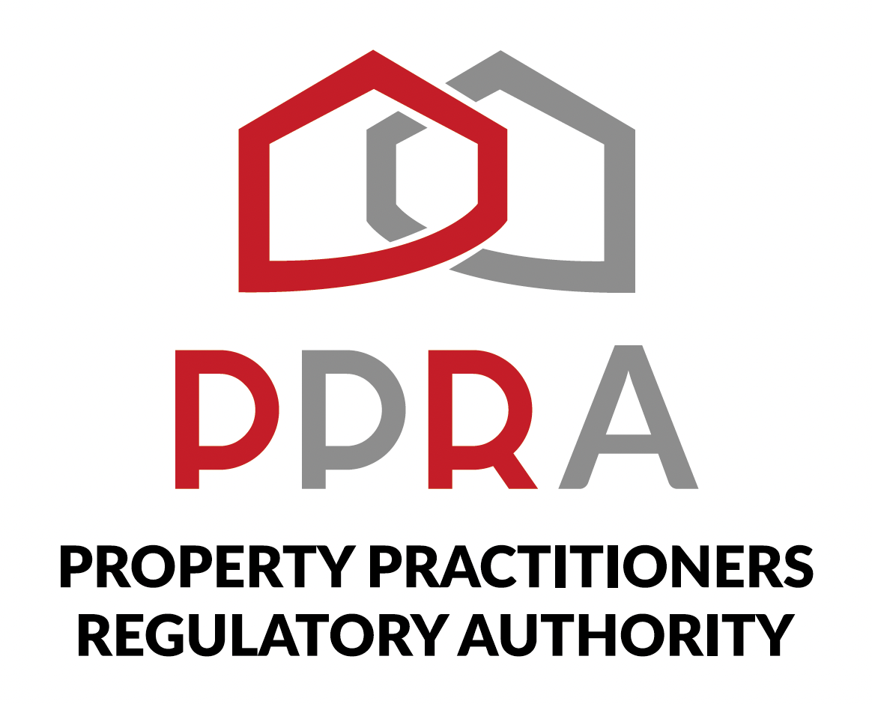
REAL ESTATE POST-TRAINING SUPPORT PROGRAMME

SESSION 4 LEARNER WORKBOOK
PPRA Continuous Professional Development (CPD)
KZN REAL ESTATE LEARNERSHIP PROGRAMME
Session 4 | 27 October 2026 | 09:00–11:00
Facilitator: Hlubi Dlomo

Item | Detail
Programme Format | Virtual Training / Masterclass
Beneficiaries | 454 Learners
Session Focus | PPRA Continuous Professional Development (CPD)
Document Status | Client-ready programme deliverable

1. Welcome
Welcome to Session 4. This workbook is your practical working document for the PPRA Continuous Professional Development (CPD) masterclass.

2. Session Information
Item | Details
Session | 4 | Week 4
Date | 27 October 2026
Time | 09:00–11:00
Focus | PPRA Continuous Professional Development (CPD)
Format | Virtual Masterclass
Facilitator | Hlubi Dlomo

3. Learning Objectives
- Understand CPD awareness and purpose.
- Understand how CPD supports professional development.
- Prepare a practical CPD plan as a new practitioner.
- Track CPD obligations and supporting evidence.
- Understand the PPRA education requirements discussed in the session.
- Engage with the CPD 2026 Curriculum Training component.

4. How to Use This Workbook
- Complete each activity during the masterclass unless instructed otherwise.
- Use current PPRA-approved information when verifying CPD or education requirements.
- Record questions that require follow-up rather than guessing.
- Keep your completed workbook as part of your programme evidence.

5. Activity 1 – My CPD Understanding
In your own words, explain what CPD means to you and how it can support your development as a property practitioner.
____________________________________________________________________________________________________
____________________________________________________________________________________________________
____________________________________________________________________________________________________
____________________________________________________________________________________________________
____________________________________________________________________________________________________
____________________________________________________________________________________________________

6. Activity 2 – My Professional Development Needs
Identify areas in which you would like to strengthen your knowledge, skills or professional practice.
Development Area | Why I Need Development | Priority / Notes

7. Activity 3 – My CPD Planning Cycle
Complete the planning cycle based on the session discussion.
Step | My Plan
1. Development need I have identified
2. CPD activity I could undertake
3. What I expect to learn or improve
4. Evidence I would retain
5. How I will review my progress

8. Activity 4 – Personal CPD Plan
Development Goal | Planned CPD Activity | Target Date | Evidence to Retain | Review

9. Activity 5 – CPD Tracking Record
Use this record to practise tracking your CPD activities.
Date | Activity | Development Area | Evidence / Reference | Status

10. Activity 6 – Evidence Checklist
Evidence Item | Available? | Where Stored / Reference
Evidence of CPD activity | Yes / No
Relevant learning material | Yes / No
Completion/participation evidence | Yes / No
Personal CPD record | Yes / No
Other supporting evidence | Yes / No

11. Activity 7 – PPRA Education Requirements
Based on the session, record what you understand about the PPRA education requirements relevant to your CPD planning. Where you are uncertain, record the question for verification.
Requirement / Topic | What I Understand | What I Need to Verify

12. Activity 8 – CPD 2026 Curriculum Training
Identify curriculum areas discussed in the CPD 2026 Curriculum Training that are relevant to your professional development.
Curriculum Area | Why It Is Relevant to Me | Planned Action

13. My CPD Questions for Follow-Up
____________________________________________________________________________________________________
____________________________________________________________________________________________________
____________________________________________________________________________________________________
____________________________________________________________________________________________________
____________________________________________________________________________________________________

14. My CPD Commitment
One CPD habit I will establish: ________________________________________________
One development area I will prioritise: ________________________________________
One record/evidence habit I will maintain: ______________________________________

15. Session 4 Reflection
What has changed in your understanding of CPD as a result of this session?
____________________________________________________________________________________________________
____________________________________________________________________________________________________
____________________________________________________________________________________________________
____________________________________________________________________________________________________
____________________________________________________________________________________________________

16. Next Session
Session 5: Real Estate Sales Practice & Digital Marketing | 03 November 2026 | 09:00–11:00

17. Document Control
Field | Detail
Document | Session 4 Learner Workbook
Version | 1.0
Programme | KZN Real Estate Learnership Programme – Post-Training Support
Date | October 2026

