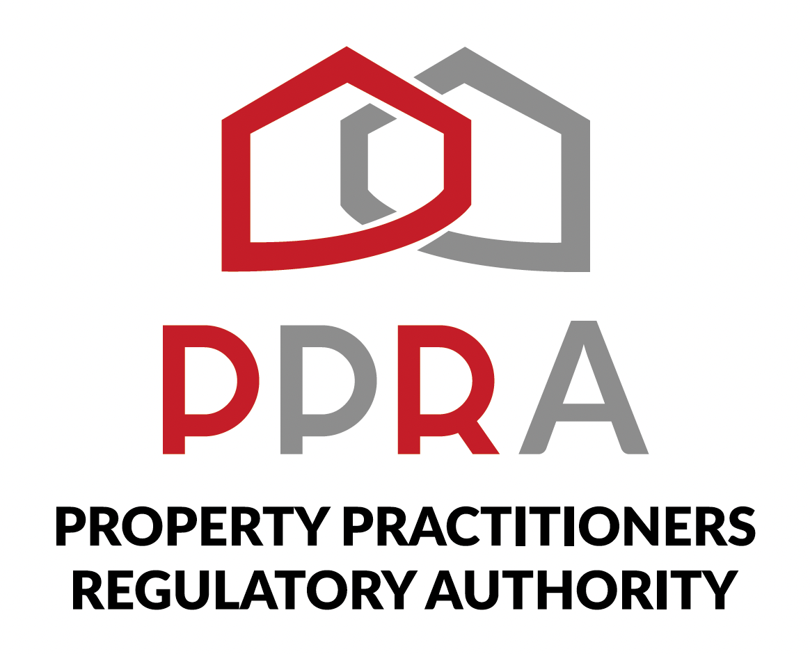
REAL ESTATE POST-TRAINING SUPPORT PROGRAMME

SESSION 3 LEARNER WORKBOOK
PPRA Practitioner Professional Obligations
KZN REAL ESTATE LEARNERSHIP PROGRAMME
Session 3 | 20 October 2026 | 09:00–11:00
Facilitator: Hlubi Dlomo

Item | Detail
Programme Format | Virtual Training / Masterclass
Beneficiaries | 454 Learners
Session Focus | PPRA Practitioner Professional Obligations
Document Status | Client-ready programme deliverable

1. Welcome
Welcome to Session 3. This workbook is your practical working document for the PPRA Practitioner Professional Obligations masterclass.

2. Session Information
Item | Details
Session | 3 | Week 3
Date | 20 October 2026
Time | 09:00–11:00
Focus | PPRA Practitioner Professional Obligations
Format | Virtual Masterclass
Facilitator | Hlubi Dlomo

3. Learning Objectives
- Understand obligations relevant to candidate and non-principal practitioners.
- Understand employment and supervision requirements.
- Recognise record keeping and reporting duties.
- Understand professional risk management.
- Understand considerations when working under a principal agency.
- Apply the topics to practical scenarios.

4. How to Use This Workbook
- Complete activities during the masterclass unless directed otherwise.
- Use current PPRA-approved information when verifying requirements.
- Record unresolved questions for follow-up.
- Keep the completed workbook as programme evidence.

5. Activity 1 – My Professional Obligations
List five professional obligations or responsibilities that you believe are important to your day-to-day practice, based on the session discussion.
Obligation / Responsibility | How It Applies to My Practice

6. Activity 2 – Employment and Supervision
Scenario: You are a candidate or non-principal practitioner working within a principal agency and are uncertain about an employment or supervision requirement.
- What should you verify?
- Who/what official source should you use to verify the requirement?
- What action should you take if the arrangement is unclear?
- What evidence or record should you retain?
____________________________________________________________________________________________________
____________________________________________________________________________________________________
____________________________________________________________________________________________________
____________________________________________________________________________________________________
____________________________________________________________________________________________________
____________________________________________________________________________________________________

7. Activity 3 – Record Keeping
Identify records that should be appropriately maintained in professional practice and explain why accurate records matter.
Record / Information | Why It Matters | My Notes

8. Activity 4 – Reporting Duties
Complete the following practical check based on the session discussion.
Question | My Response
What reporting responsibility did I learn about?
When would I need to verify a reporting requirement?
What source should I use?
What evidence should I retain?

9. Activity 5 – Professional Risk Management
Identify three situations that could create professional risk and record a responsible response.
Potential Risk | Preventive / Responsible Action | Evidence / Record

10. Activity 6 – Working Under a Principal Agency
Area | Practitioner Responsibility / Consideration | Question for Follow-Up
Employment / working arrangement
Supervision
Records
Communication / reporting
Compliance

11. Activity 7 – Scenario Challenge
Scenario | Obligation Involved | What Must Be Verified? | Action / Evidence
A practitioner is unsure about the supervision arrangement.
A practitioner discovers that an important professional record is incomplete.
A practitioner is uncertain whether a matter requires reporting.
A practitioner identifies a situation that may create professional risk.

12. My Professional Obligations Action Plan
Action / Follow-Up | Reason | Target Date | Evidence / Reference

13. Questions for Follow-Up
____________________________________________________________________________________________________
____________________________________________________________________________________________________
____________________________________________________________________________________________________
____________________________________________________________________________________________________
____________________________________________________________________________________________________

14. Session 3 Reflection
What professional obligation will you pay greater attention to as a result of this session, and why?
____________________________________________________________________________________________________
____________________________________________________________________________________________________
____________________________________________________________________________________________________
____________________________________________________________________________________________________

15. Session 3 Take-Away
My key professional obligation: ______________________________________________
I will verify my requirement using: __________________________________________
Evidence/record I will maintain: ______________________________________________

16. Next Session
Session 4: PPRA Continuous Professional Development (CPD) | 27 October 2026 | 09:00–11:00

17. Document Control
Field | Detail
Document | Session 3 Learner Workbook
Version | 1.0
Programme | KZN Real Estate Learnership Programme – Post-Training Support
Date | October 2026

