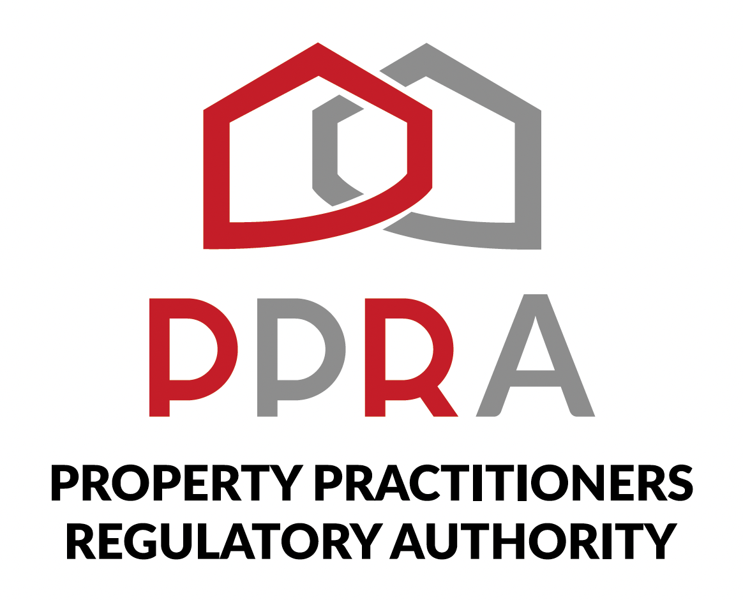
REAL ESTATE POST-TRAINING SUPPORT PROGRAMME

SESSION 2 LEARNER WORKBOOK
PPRA Practitioner FFC Compliance
KZN REAL ESTATE LEARNERSHIP PROGRAMME
Session 2 | 13 October 2026 | 09:00–11:00
Facilitator: Hlubi Dlomo

Item | Detail
Programme Format | Virtual Training / Masterclass
Beneficiaries | 454 Learners
Session Focus | PPRA Practitioner FFC Compliance
Document Status | Client-ready programme deliverable

1. Welcome
Welcome to Session 2. This workbook is your practical working document for the PPRA Practitioner FFC Compliance masterclass.

2. Session Information
Item | Details
Session | 2 | Week 2
Date | 13 October 2026
Time | 09:00–11:00
Focus | PPRA Practitioner FFC Compliance
Format | Virtual Masterclass
Facilitator | Hlubi Dlomo

3. Learning Objectives
- Understand the FFC compliance areas covered.
- Recognise the status and renewal obligations topic.
- Understand change of employment requirements/process.
- Understand FFC Status Upgrade.
- Distinguish practitioner and firm compliance.
- Create a personal follow-up plan.

4. How to Use This Workbook
- Complete activities during the masterclass unless directed otherwise.
- Use official PPRA information when verifying requirements.
- Record unresolved questions rather than guessing.
- Keep the completed workbook as programme evidence.

5. Activity 1 – My FFC Compliance Understanding
In your own words, explain why an active property practitioner needs to understand and manage FFC compliance.
____________________________________________________________________________________________________
____________________________________________________________________________________________________
____________________________________________________________________________________________________
____________________________________________________________________________________________________
____________________________________________________________________________________________________

6. Activity 2 – FFC Status and Renewal Check
Use official information to complete this checklist. If an item cannot be verified during the session, mark it “Follow Up”.
Check | Status / Notes
I understand the FFC status topic.
I know where to verify my current PPRA status.
I understand the renewal obligation topic.
I know what evidence to retain after a compliance action.
I have identified any personal renewal follow-up.

7. Activity 3 – Change of Employment Scenario
Scenario: Your employment/firm circumstances change and you are unsure whether your PPRA records and FFC position need attention.
- What should you verify first?
- What PPRA process or requirement should you check?
- What information/evidence would you prepare?
- What evidence would you retain after the action?
____________________________________________________________________________________________________
____________________________________________________________________________________________________
____________________________________________________________________________________________________
____________________________________________________________________________________________________
____________________________________________________________________________________________________
____________________________________________________________________________________________________
____________________________________________________________________________________________________
____________________________________________________________________________________________________

8. Activity 4 – FFC Status Upgrade
Before pursuing an FFC Status Upgrade, identify the information you would verify from current PPRA requirements.
Information to Verify | My Notes
Current practitioner status
Applicable upgrade requirement/process
Supporting information/documentation
Where the action is completed
Evidence of submission/outcome

9. Activity 5 – Practitioner vs Firm Compliance
Practitioner-Level Matter | Firm-Level Matter

10. Activity 6 – Compliance Scenario Challenge
Scenario | Compliance Topic | What Must Be Verified? | Action / Evidence
Confirm FFC position before continuing practice.
Change of employment/firm circumstances.
Considering an FFC Status Upgrade.
Operating through or establishing a firm.

11. My FFC Compliance Action Plan
Action | Why Required | Target Date | Evidence / Reference

12. Questions for Follow-Up
____________________________________________________________________________________________________
____________________________________________________________________________________________________
____________________________________________________________________________________________________
____________________________________________________________________________________________________
____________________________________________________________________________________________________

13. Session 2 Reflection
What is the most important FFC compliance understanding you are taking from this session?
____________________________________________________________________________________________________
____________________________________________________________________________________________________
____________________________________________________________________________________________________
____________________________________________________________________________________________________

14. Session 2 Take-Away
My next compliance action is: ________________________________________________
I will verify the requirement using: __________________________________________
Evidence I will retain: ______________________________________________________

15. Next Session
Session 3: PPRA Practitioner Professional Obligations | 20 October 2026 | 09:00–11:00

16. Document Control
Field | Detail
Document | Session 2 Learner Workbook
Version | 1.0
Programme | KZN Real Estate Learnership Programme – Post-Training Support
Date | October 2026

