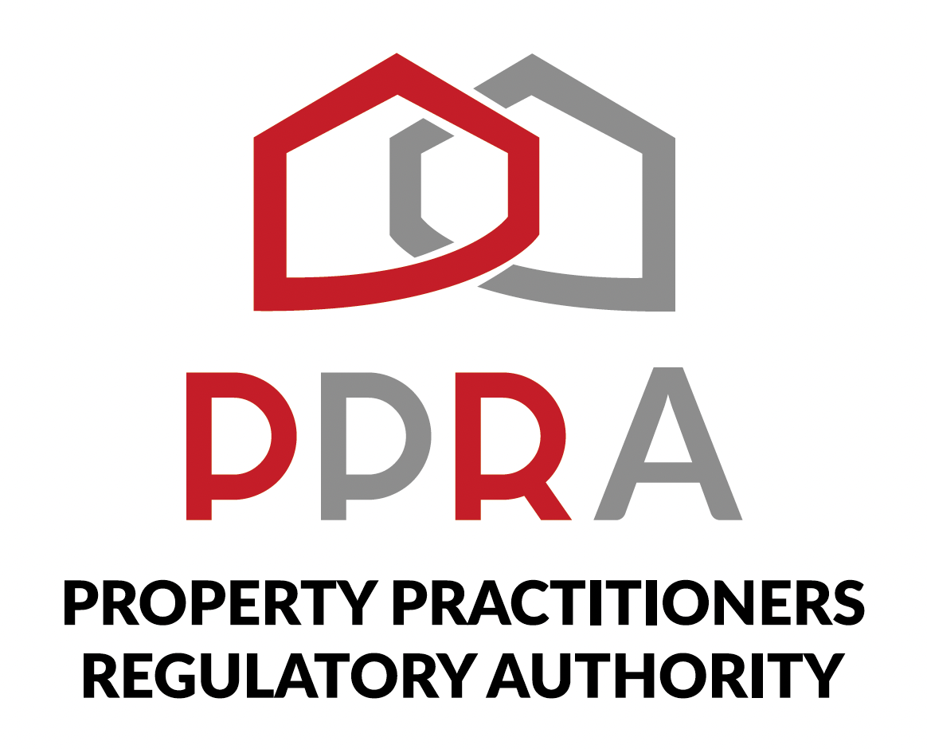
REAL ESTATE POST-TRAINING SUPPORT PROGRAMME
━━━━━━━━━━━━━━━━━━━━━━━━━━━━━━━━━━━━━━━━━━━━━━━━━━━━━━━━━━━━━━━━━━━━━━━━━━━━━━━━━━━━━━━━
POST-TRAINING SUPPORT PROGRAMME
KZN REAL ESTATE LEARNERSHIP PROGRAMME
SESSION 1 LEARNER WORKBOOK
Virtual Onboarding & Digital Readiness
06 October 2026 | 09:00–11:00 | Virtual
Programme | KZN Real Estate Learnership Programme | Session | 1 of 10
Beneficiaries | 454 Learners | Facilitator | Hlubi Dlomo
Format | Virtual Training / Masterclass | Cohort | Joint Virtual Cohort
Duration | 2 Hours | Delivery | Zoom / PPRA Post-Training Support Platform
LEARNER-FACING TRAINING RESOURCE

1. Welcome to Session 1
Welcome to Session 1 of the PPRA KZN Real Estate Learnership Programme Post-Training Support Programme. This session is designed to ensure that you are digitally ready to participate fully in the 10-week programme.
During this session, you will become familiar with the Real Estate Post-Training Support Platform, confirm your access and registration, locate your digital learning materials and masterclass toolkits, learn how assignments will be submitted, and understand the standards that apply to participation in the virtual classroom.
Your goal for today
By the end of this session, you should be able to independently access the programme's digital environment, find the resources you need and understand how you will participate in the remaining sessions.

2. Session Information
Session | Session 1 of 10
Masterclass | Virtual Onboarding & Digital Readiness
Date | 06 October 2026
Time | 09:00–11:00
Format | Virtual Training / Masterclass
Facilitator | Hlubi Dlomo
Cohort | Joint Virtual Cohort

3. What You Will Learn
By the end of this session, you should be able to:
- Access and navigate the Real Estate Post-Training Support Platform.
- Complete or confirm your platform registration.
- Locate your digital study materials.
- Locate the masterclass toolkits and other programme resources.
- Identify the assignment submission area.
- Understand the expectations for virtual classroom participation.
- Understand how attendance and participation are recorded.
- Identify the correct channel for programme communication and support.
- Recognise and report any access or technical problem that may affect your participation.

4. How to Use This Workbook
Keep this workbook available during the session. You will be asked to complete practical checks, record information, confirm your access and complete the Digital Readiness Checklist. Use the spaces provided to make notes and record any issues that require follow-up.
- Follow the facilitator's live demonstration.
- Complete each practical activity on your own device where possible.
- Ask questions when you encounter a problem.
- Record any unresolved access or technical issue.
- Complete the Digital Readiness Checklist before the end of the session.

5. Your 10-Week Programme Journey
The Post-Training Support Programme is delivered through 10 weekly virtual masterclasses. Session 1 establishes your digital readiness so that you can participate effectively in the sessions that follow.
Session | Date | Masterclass | Purpose
1 | 06 October | Virtual Onboarding & Digital Readiness | Getting ready for the digital learning environment.
2 | 13 October | PPRA Practitioner FFC Compliance | FFC status, renewal, employment changes, upgrades and firm requirements.
3 | 20 October | PPRA Practitioner Professional Obligations | Professional obligations, supervision, records, reporting and risk management.
4 | 27 October | PPRA Continuous Professional Development (CPD) | CPD awareness, planning, tracking and PPRA education requirements.
5 | 03 November | Real Estate Sales Practice & Digital Marketing | Sales execution, mandates, objections, pipeline management and digital marketing.
6 | 10 November | Client Management & Personal Branding | Client onboarding, communication, relationships and professional brand.
7 | 17 November | CRM, Client Pipeline & Business Management | CRM, lead management, POPIA and a one-page business plan.
8 | 24 November | CIPC BizPortal, SARS Tax Admin & Financial Literacy | Business registration, tax administration and real estate financial literacy.
9 | 01 December | Portfolio Review, Assessment & Certification | Portfolio review, final competency assessment, evaluation and certification.
10 | 08 December | Programme Closing and Reviews | Programme review, questions and way forward.

6. Activity 1 — Platform Access & Registration Check
Your first task is to confirm that you can access the Real Estate Post-Training Support Platform and that your registration or login details are working.

Follow these steps
- Open the Real Estate Post-Training Support Platform.
- Locate the registration or login area.
- Register or log in using the details provided to you.
- Confirm that you can reach your programme area.
- Identify where your programme information is displayed.
- If you cannot access the platform, tell the facilitator before moving on.
My access status: ☐ Access confirmed ☐ Registration completed ☐ Assistance required
My platform/login notes:
________________________________________________________________________________
________________________________________________________________________________
________________________________________________________________________________
________________________________________________________________________________

7. Activity 2 — Platform Navigation
Follow the facilitator's demonstration and then repeat the navigation steps yourself. The purpose of this activity is to ensure that you can find the main areas you will use during the programme.
Area to Locate | Found? | Notes / Location
Programme information | ☐ Yes ☐ No
Learning materials | ☐ Yes ☐ No
Masterclass toolkit | ☐ Yes ☐ No
Assignment/submission area | ☐ Yes ☐ No
Any learner support or communication area | ☐ Yes ☐ No
What did you find easiest to locate?
________________________________________________________________________________
What did you need help finding?
________________________________________________________________________________

8. Activity 3 — Accessing Digital Learning Materials
The programme uses digital learning materials and masterclass toolkits to support your learning between and during sessions. You should know where these resources are located and how to access them.

Complete the resource check
Resource | Located | Opened/Accessed | Notes
Session 1 learner materials | ☐ Yes ☐ No | ☐ Yes ☐ No
Session 1 masterclass toolkit | ☐ Yes ☐ No | ☐ Yes ☐ No
Programme learning resources | ☐ Yes ☐ No | ☐ Yes ☐ No
Any available supporting digital resource | ☐ Yes ☐ No | ☐ Yes ☐ No
Good practice
Keep your programme learning materials organised so that you can return to them during the 10-week programme. Your completed practical activities may also be used as evidence of your learning and participation.

9. Activity 4 — Assignment Submission Portal
You will complete practical activities during the programme. This activity introduces you to the area where assignments or practical submissions will be made.
- Open the assignment/submission area.
- Identify where a learner would find an assignment or practical activity.
- Identify where a completed submission would be uploaded or submitted, where applicable.
- Confirm how you would know that your submission has been completed successfully.
- Ask the facilitator to clarify anything you do not understand.
Submission portal access: ☐ Confirmed ☐ Assistance required
My notes about submitting assignments:
________________________________________________________________________________
________________________________________________________________________________
________________________________________________________________________________
________________________________________________________________________________

10. Digital Learning Protocols & Governance
Professional conduct applies to the virtual classroom in the same way that it applies to a professional workplace. The following standards will help us maintain an effective learning environment.
Standard | What It Means for You
Be punctual | Join the scheduled session on time and be ready to participate.
Participate actively | Take part in discussions, demonstrations and practical activities.
Communicate respectfully | Treat the facilitator and other learners professionally and respectfully.
Follow attendance requirements | Make sure your attendance is captured according to the programme process.
Use the agreed communication channels | Use the official programme communication and support channels for programme information and assistance.
Protect your access information | Keep your login and access details secure.
Report problems early | Tell the programme team when an access or technical issue prevents you from participating.
Keep your learning resources | Retain your programme materials and completed activities for future reference.

11. Reflection — My Digital Learning Readiness
Which part of the platform can I access confidently?
________________________________________________________________________________
________________________________________________________________________________
What part of the platform do I still need help with?
________________________________________________________________________________
________________________________________________________________________________
Do I know where to find my learning materials?
________________________________________________________________________________
________________________________________________________________________________
Do I know where assignments will be submitted?
________________________________________________________________________________
________________________________________________________________________________
What could prevent me from participating fully in a future virtual session?
________________________________________________________________________________
________________________________________________________________________________
What action will I take to address that issue?
________________________________________________________________________________
________________________________________________________________________________

12. Digital Readiness Checklist
Complete this checklist before the end of Session 1. Tick each item only when you have personally confirmed it.
No. | Readiness Requirement | Completed
1 | Platform registration/login completed or confirmed. | ☐
2 | Post-Training Support Platform accessed successfully. | ☐
3 | Programme information located. | ☐
4 | Session learning materials located. | ☐
5 | Masterclass toolkit located. | ☐
6 | Assignment submission area located. | ☐
7 | Virtual classroom participation expectations understood. | ☐
8 | Attendance process understood. | ☐
9 | Programme communication/support channel identified. | ☐
10 | Any access or technical issue has been reported. | ☐
Learner Name: ______________________________________________________________
Learner Signature / Confirmation: __________________________________________
Date: __________________________

13. Access & Technical Issues Log
Use this section to record any problem that affects your ability to access the platform, learning materials or assignment area.
Issue | Where / What Happened | Reported To | Action / Resolution

14. Session 1 Knowledge & Readiness Check
Complete the following questions after the session. The purpose of this check is to confirm that you understand the digital participation requirements introduced during Session 1.
1. What is the main purpose of the Real Estate Post-Training Support Platform?
Answer:
________________________________________________________________________________
________________________________________________________________________________
2. Where will you access your digital study materials and masterclass toolkits?
Answer:
________________________________________________________________________________
________________________________________________________________________________
3. Where will programme assignments or practical activities be submitted?
Answer:
________________________________________________________________________________
________________________________________________________________________________
4. Why is attendance tracking important in the programme?
Answer:
________________________________________________________________________________
________________________________________________________________________________
5. What should you do if you experience an access or technical problem?
Answer:
________________________________________________________________________________
________________________________________________________________________________
6. List two standards that will help maintain a professional virtual classroom.
Answer:
________________________________________________________________________________
________________________________________________________________________________

15. My Programme Participation Commitment
The Post-Training Support Programme is designed to support my transition into active early-practice participation. I understand that successful participation requires me to attend the scheduled sessions, engage with the learning materials, complete practical activities and communicate issues that may affect my participation.
- ☐ I will make reasonable arrangements to attend the scheduled virtual sessions.
- ☐ I will access the programme platform and learning resources as required.
- ☐ I will participate professionally and respectfully.
- ☐ I will complete the practical activities and submissions required during the programme.
- ☐ I will raise access or technical problems promptly.
- ☐ I will retain my learning materials and completed activities for future reference.
My personal commitment for the programme:
________________________________________________________________________________
________________________________________________________________________________
________________________________________________________________________________

16. Session 1 Take-Away
Before you leave Session 1, make sure you can answer “yes” to these questions:
Can I access the platform? Can I find my learning materials? Can I find the masterclass toolkit? Do I know where assignments will be submitted? Do I understand attendance and participation expectations? Do I know where to get programme support?

17. Next Session
The next masterclass is Session 2: PPRA Practitioner FFC Compliance. The session will focus on FFC status and renewal obligations, change of employment requirements and process, FFC Status Upgrade, PPRA Firm Registration and Firm FFC requirements.
Next session: 13 October 2026 | 09:00–11:00 | Virtual

18. Notes
________________________________________________________________________________
________________________________________________________________________________
________________________________________________________________________________
________________________________________________________________________________
________________________________________________________________________________
________________________________________________________________________________
________________________________________________________________________________
________________________________________________________________________________

Document Control
Document Title | Session 1 Learner Workbook — Virtual Onboarding & Digital Readiness
Programme | PPRA KZN Real Estate Learnership Programme — Post-Training Support Programme
Session | Session 1 of 10
Scheduled Date | 06 October 2026
Scheduled Time | 09:00–11:00
Facilitator | Hlubi Dlomo
Beneficiary Cohort | 454 Learners
Document Purpose | Learner-facing workbook and practical readiness resource
Status | Programme Delivery Document

