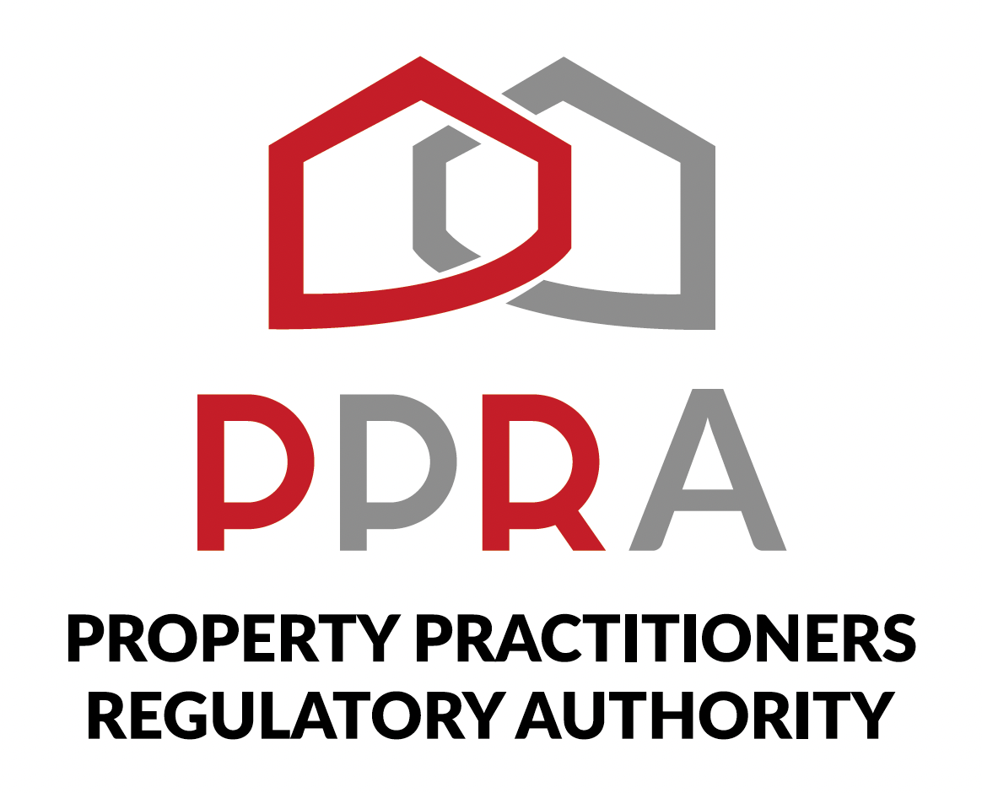
REAL ESTATE POST-TRAINING SUPPORT PROGRAMME

LEARNER WORKWOOK
PROGRAMME CLOSING AND REVIEWS

Session | Session 10
Date | 8 December 2026
Time | 09:00–11:00
Facilitator | PPRA / Facilitator

Welcome to the Final Programme Session
This workbook supports your participation in the final programme closing and review session. Use it to reflect on your learning journey, record outstanding questions, capture feedback and define your way forward.
Session at a Glance
Session 10 | 8 December 2026 | 09:00–11:00 | Facilitator: PPRA / Facilitator

1. My Programme Journey
Session / Area | What I Remember | What I Will Apply
Sessions 1–4: Digital readiness, PPRA compliance, professional obligations & CPD
Sessions 5–6: Sales, digital marketing, client management & personal branding
Sessions 7–8: CRM, business management, CIPC, SARS & financial literacy
Session 9: Portfolio review, assessment & certification

2. My Key Learning
The three most useful things I learned during the programme are:
________________________________________________________________________________
________________________________________________________________________________
________________________________________________________________________________
The practical skill I most want to apply in my real estate practice is:
________________________________________________________________________________
________________________________________________________________________________
The area where I still need support or more practice is:
________________________________________________________________________________
________________________________________________________________________________

3. Programme Review Checklist
Programme Area | I Can Apply This | I Need More Practice | I Need Clarification
Digital learning / platform participation | ☐ | ☐ | ☐
PPRA compliance and professional obligations | ☐ | ☐ | ☐
CPD awareness and planning | ☐ | ☐ | ☐
Sales practice and digital marketing | ☐ | ☐ | ☐
Client management and communication | ☐ | ☐ | ☐
Personal branding | ☐ | ☐ | ☐
CRM and client pipeline management | ☐ | ☐ | ☐
Business management and planning | ☐ | ☐ | ☐
CIPC BizPortal and business administration | ☐ | ☐ | ☐
SARS tax administration | ☐ | ☐ | ☐
Real estate financial literacy | ☐ | ☐ | ☐

4. My Outstanding Questions
Question | Programme Area | What I Need Clarified | Follow-Up

5. My Programme Feedback
Feedback Area | My Feedback
Most useful topic
Most useful practical activity
Most useful resource
Area needing more support
Virtual delivery experience
Suggestions for future programmes

6. My Way Forward
Use this section to identify practical actions you will take after the programme.
Action | Why It Matters to My Practice | Target Date | Status

7. My 30-Day Practice Commitments
Commitment | First Step | Target Date

8. Final Reflection
How has the programme prepared me for the next stage of my real estate practice?
________________________________________________________________________________
________________________________________________________________________________
________________________________________________________________________________
What will I do differently as a result of this programme?
________________________________________________________________________________
________________________________________________________________________________
What support would be most useful to me going forward?
________________________________________________________________________________
________________________________________________________________________________

9. Learner Confirmation
I have participated in the programme closing and review session and have recorded my reflections, feedback, questions and intended next steps.
Learner Name | Date | Signature / Confirmation

